Chapter 4 Introductory Script and

Chapter 4 Popper begun

We will be strictly Euclidean in this chapter and in Chapter 5 and then get back to the Big Three in Chapter 6 for a review.

Here, we are in the plane and we are moving shapes around with reflections, rotations, translations, and glide reflections. These 4 movements are called “rigid motions in the plane”. Now there is really just one way to accomplish all of these motions: using a reflection or two or three. We will flip the objects over and out of the plane to reverse orientation using a reflection about a line. We’ll be working in two dimensions except for the reflection itself.

Let’s look at a 3 dimensional reflection across a plane just for a moment. Hold your hands up in front of you palms facing one another. Do you see that your right hand and left hand are a reflection of each another across a plane between them? And that the orientation is reversed? Your thumb is on the left of your right and the right of your left hand. This is the basic “rigid motion”. And the reversed orientation is further illustrated by the fact that you have to turn a glove inside out to use it for the other hand!

The other motions are a string of reflections across carefully chosen lines. We will look at each in turn in the upcoming videos. When you have a series of reflections you combine them with an operation called Composition. Which is exactly the same operation as composing functions in College Algebra. And that’s because each reflection is, in fact, a function with an input value of a set of initial points or initial image and the output is a set of points called the final points or final image.

Let’s look at a checkmark to see a reflection across a line, the y-axis. Remember this is x goes to –x in our notation f(x, y) (initial) goes to f(-x, y) (final)!

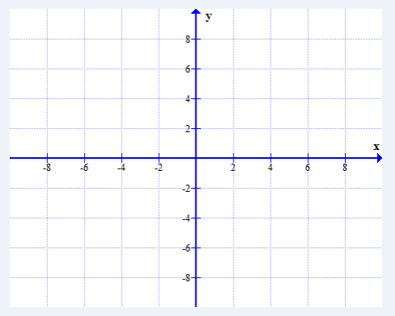

This move is an **isometry** – it doesn’t change segment lengths or angle measures. So it’s different from a similarity transform…which does change segment lengths. They both change locations though. There will be an initial point set and a final point set just like with similarity transforms in Chapter 3. In Greek “isos” means same and “metry” means measured.

There are isometries and similarity transforms in Spherical Geometry and Hyperbolic Geometry, but they are well beyond the scope of the class!

So these transforms are usually taught separately, but we’re going to learn them as one unit. The outline is as follows:

Transformations

1. Similarities (Chapter 3)
2. Isometries – aka **Rigid Motions in the Plane** (Chapter 4)
   1. Orientation Reversing
      1. Reflection (one reflection)

About one line

* + 1. Glide Reflection (three reflections)

Twice along and then across one line

* 1. Orientation Preserving
     1. Translation (two reflections)

About two parallel lines

* + 1. Rotation (two reflections)

About two intersecting lines

I have not put the videos in this order because I’m doing one reflection first, then the 2 two reflections and finally the 3 reflections. But once you know them you can mix them in any order!

I also decided to have only one popper: a Chapter 4 Popper that will string along through all the videos.

Orientation Reversing moves (Reflection and Glide Reflection) are sometimes called Odd (for the number of lines and moves) or Indirect motions.

Orientation Preserving moves (Translation and Rotation) are sometimes called Even for the number of lines and moves aka Direct motions.

**Chapter 4 Popper Question 1**

The 4 Rigid Motions in the Plane are all isometries.

A. True

B. False

Combining reflections:

Now composition is called for with a tiny hollow dot  . And it does not commute. Remember addition and multiplication commute (eg 3 + 5 = 5 + 3 and 3(5) = 5(3)). Composition is more like subtraction or division which do not usually commute. 3/5 is not equal to 5/3 and likewise 3-5 is not equal to 5-3. We’ll come back to this notion when we look at translations in the plane.

So when we specify a Rotation about a point C of 30 degrees (Rot(C, 30)) to a given initial object, we can also say Reflect first about Line 1 and then about Line 2 for carefully chosen lines and end up with the SAME final set. Now let’s look carefully at how we’d say that with an R, for reflection. R2(L2) R1(L1) initial object.  means “after” so this says do reflection 2 about line 2 AFTER you do reflection 1 about line 1.

This takes some practice so let’s do another one

A glide reflection would be GR(L1) to a given initial object. This is then 3 reflections which I’ll write out in short hand: R3R2R1 (line) initial object.

**Chapter 4 Popper Question 2**

Suppose I have 2 rigid motions: A and B. I want my students to do A first and B second. How do I write their instructions?

A. AB

B. BA

Ok now, let’s start studying the basic rigid motion: **Reflection** in the next video.

See you there!

Two popper questions in this video. No essays or homework problems yet.